**How does web browsers work?**

A browser is a software application used to locate, retrieve and display content on the World Wide Web, including Web pages, images, video and other files. As a client/server model, the browser is the client run on a computer that contacts the Web server and requests information. The Web server sends the information back to the Web browser which displays the results on the computer or other Internet-enabled device that supports a browser.

The way the browser interprets and displays HTML files is specified in the HTML and CSS specifications.

The basic layout of the browser architecture is:

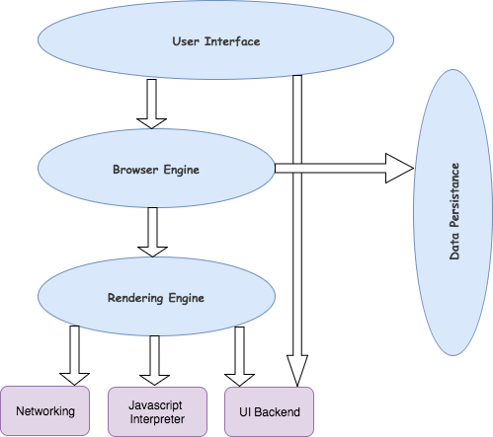

The main components of a browser are

* Browser UI
* Browser engine
* Rendering engine
* Networking module
* Javascript engine/interpreter
* UI backend
* Local data storage/browser cache memory.

Main components :

The user interface: this includes the address bar, back/forward button, bookmarking menu, etc. Every part of the browser display except the window where you see the requested page.

The browser engine: marshals actions between the UI and the rendering engine.

The rendering engine : responsible for displaying requested content. For example if the requested content is HTML, the rendering engine parses HTML and CSS, and displays the parsed content on the screen.

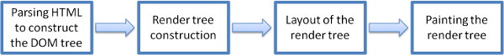

Networking: for network calls such as HTTP requests, using different implementations for different platform behind a platform-independent interface.

UI backend: used for drawing basic widgets like combo boxes and windows. This backend exposes a generic interface that is not platform specific. Underneath it uses operating system user interface methods.

JavaScript interpreter. Used to parse and execute JavaScript code.

Data storage. This is a persistence layer. The browser may need to save all sorts of data locally, such as cookies. Browsers also support storage mechanisms such as localStorage, IndexedDB, WebSQL and FileSystem.